Lesson 4

For ever and a day
Writing C programs in a way in which you get the computer to repeat a set of code is very useful since it reduces the number of statements in the program. An instruction that does this is a ‘for’ loop. In C the single statement form of the ‘for’ loop the syntax is as follows.
for(initialise section;test section;end of loop section)
statement;
A multiple statement may replace the single statement. As an example of the for loop try the following piece of code.
void main(void)
{
int total,index,list[10];
for(total=0,index=0;index<10;index++)
{
printf(“Enter the element %d”,index);
scanf(“%d”,&list[index]);
total =total +list[index];
}
}
These are the stages, which the above code will pass through.
Step 1 | Set Total to 0. Set Index to 0
Step 2 | Test Index <10 if true go to Step 3 otherwise go to Step 8
Step 3 | Print message
Step 4 | Scan and store list value
Step 5 | Add the total to the list value and store back in the total
Step 6 | Increase Index
Step 7 | Loop back to step 2
Step 8 | End

Exercise
Write a program to enter a list of numbers; find the average of the list, and then the program should use a loop to redisplay the numbers after they have been entered.
An extra enhancement to the program could be to test if the entered number is above or below the average. Further develop the program to calculate the standard deviation of the data and then display if the number is within one, two or three standard deviations of the average.
The formula for standard deviation is 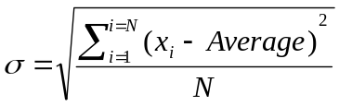
Formula explanation standard deviation is the square root of the following sum. For each of the numbers in the list from the 1st to N^{th} item square the difference between the item and the average. Add all of these squares and divide this by the number of items.

